**24-677 Modern Control Theory  
Project 4**

**Exercise 1:**

1. **100 Step Kalman Filter**

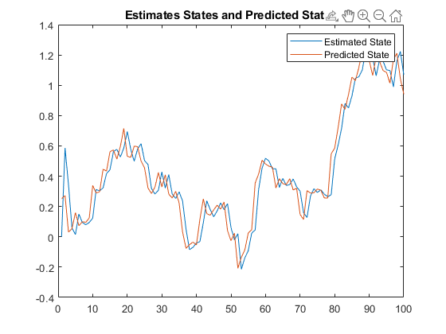

Figure 1: Graph of Estimated and Predicted States

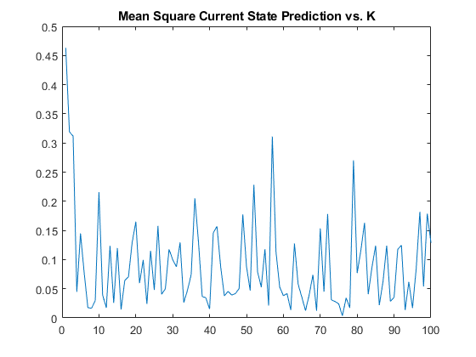

Figure 2: Graph of Mean Square Current State Prediction Error vs K

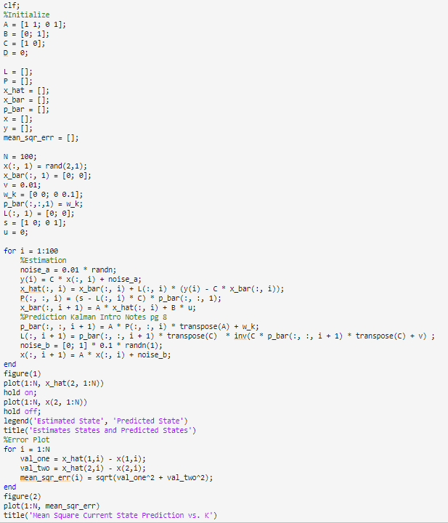

Figure 3: Code for Exercise 1.1

1. **Kinematic Kalman Filter**

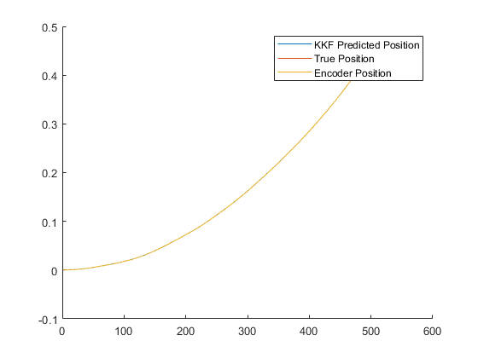

Figure 4: Graph of True State, Position State, and Encoder State

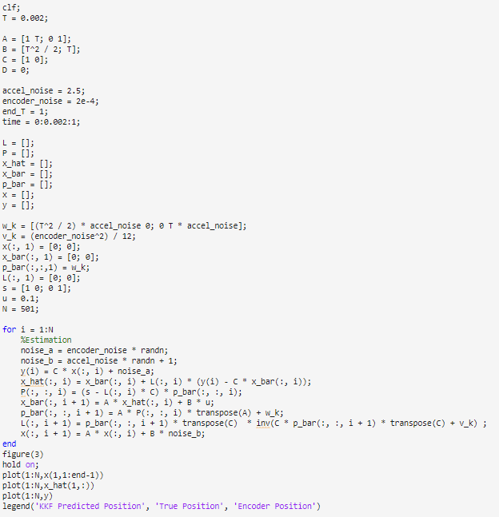

Figure 5: Code for Exercise 1.2

**Exercise 2:**

